**Data Visualizations**

**Plotting the trips by hours in a day**

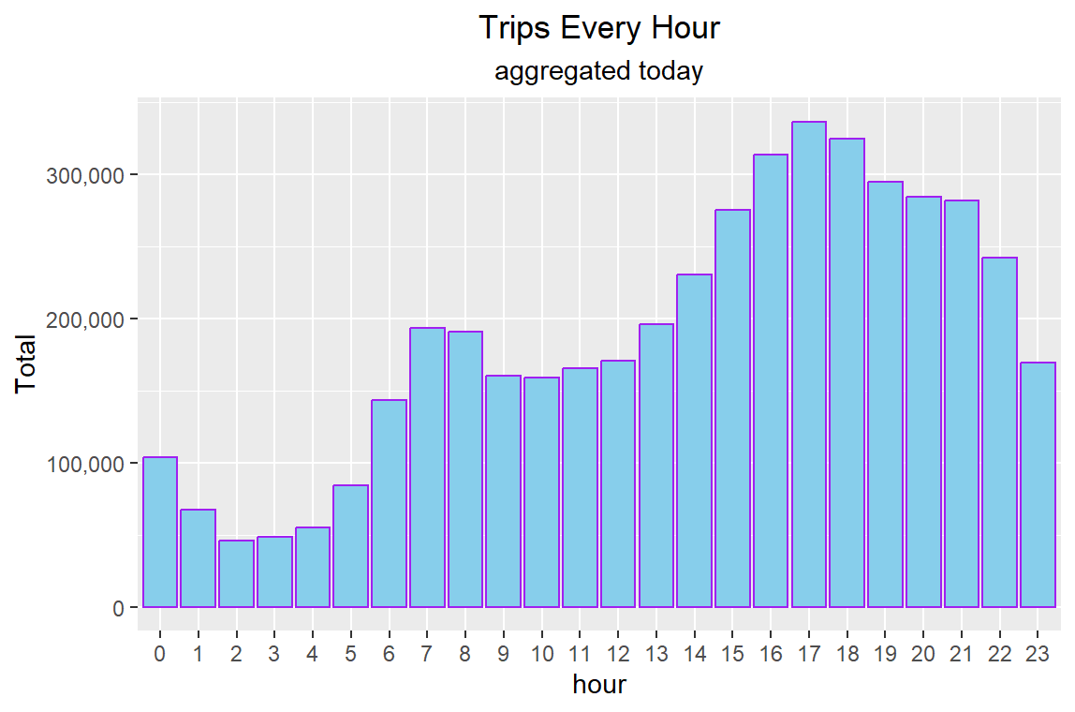

**Plotting trips by hour and month**

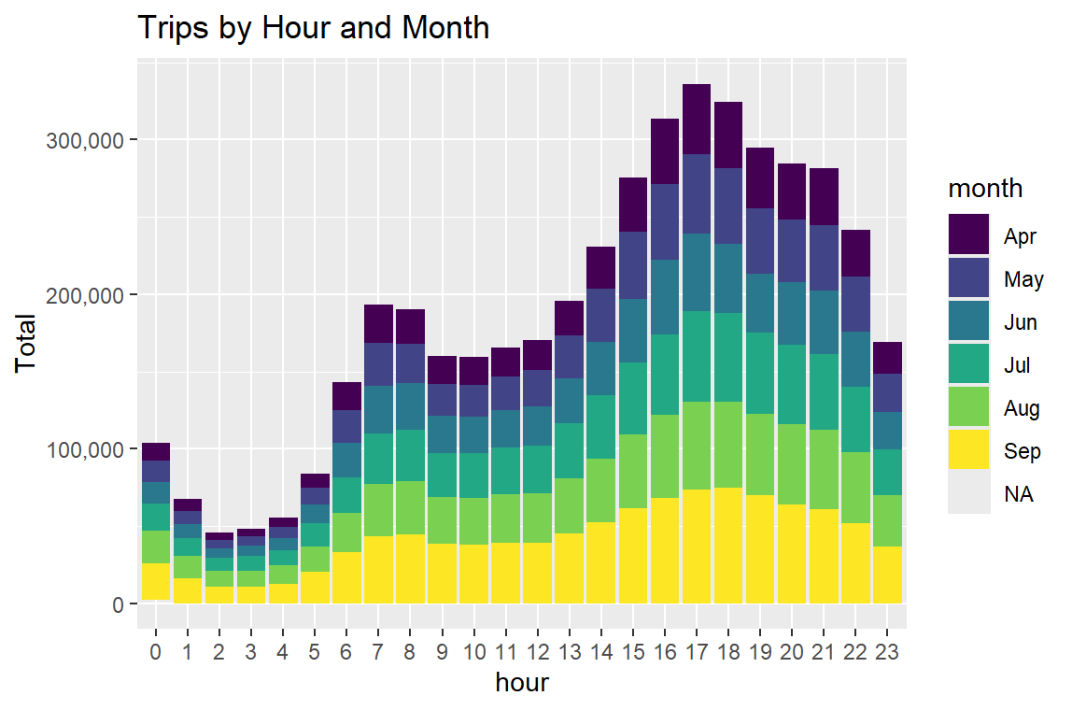

**Plotting data by trips during every day of the month**

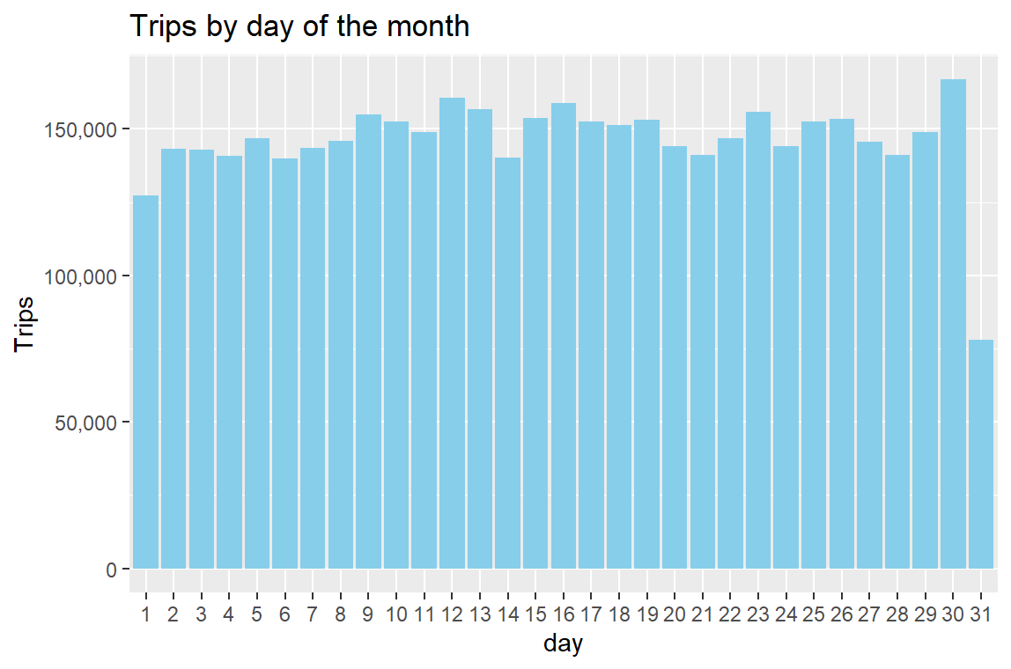

**Collect data by day of the week and month**

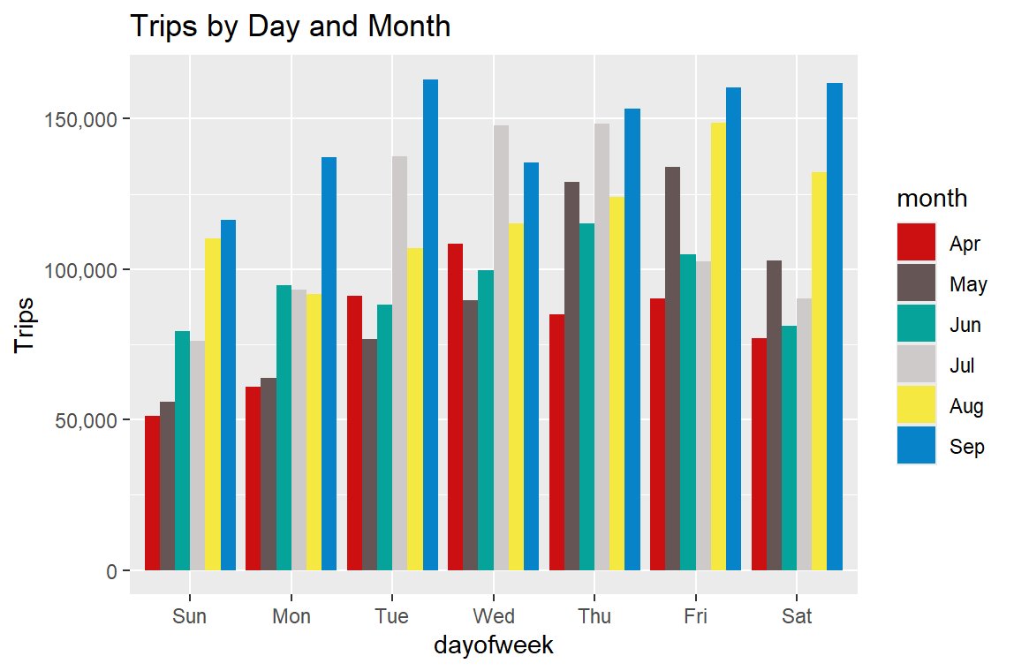

**Number of Trips place during months in a year**

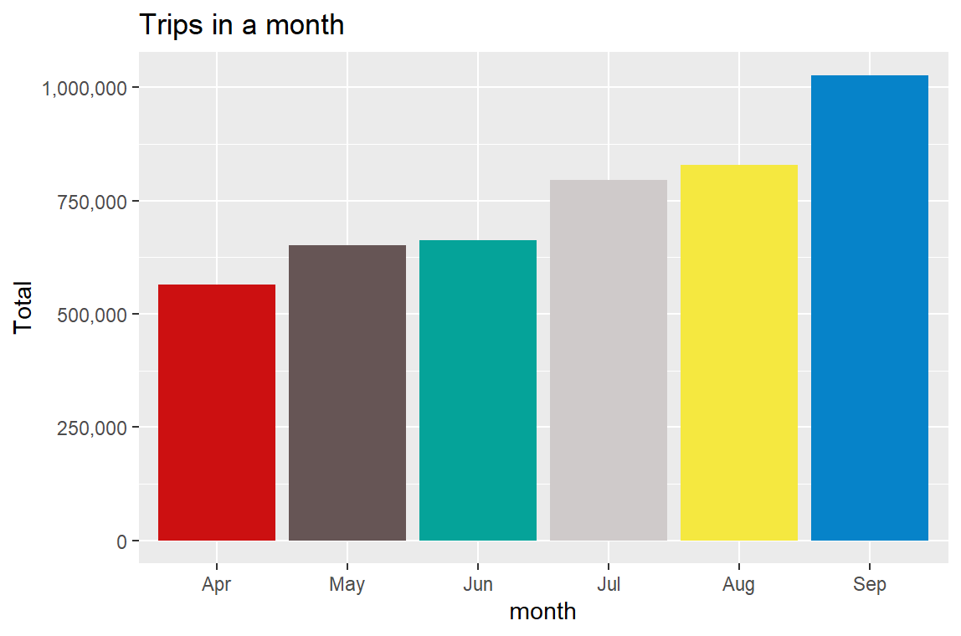

**Heatmap by Hour and Day**

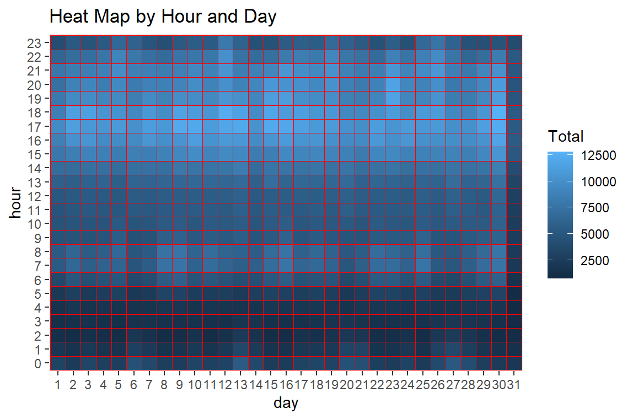

**Plot Heatmap by day and month**

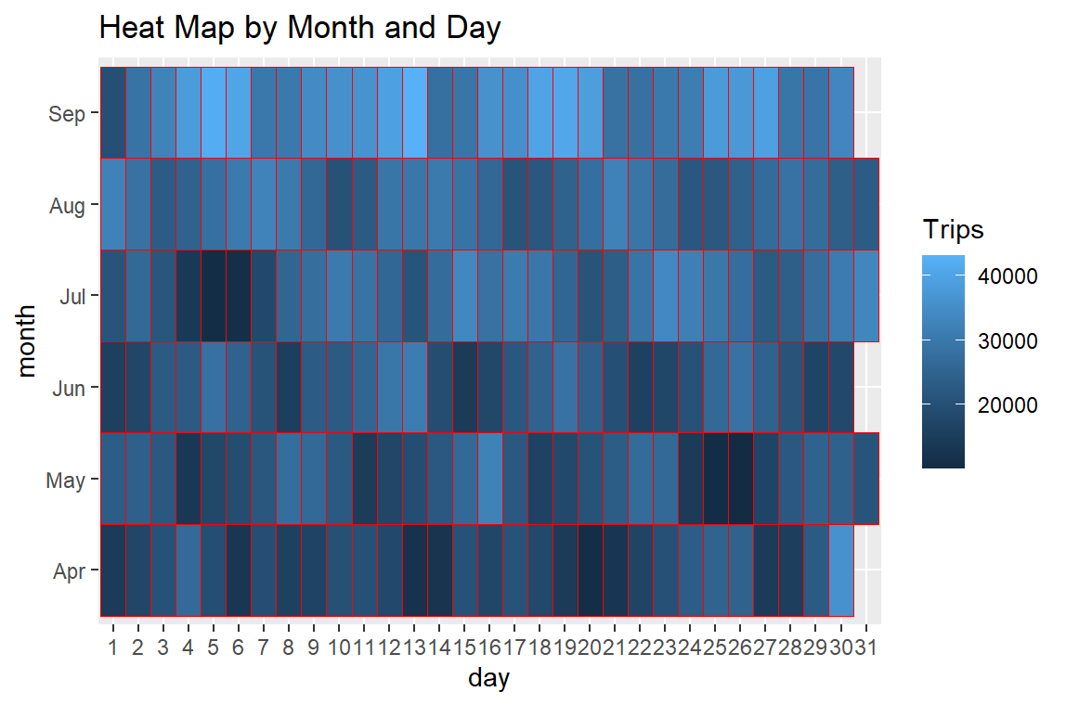

**Plot a heatmap by day of the week and month**

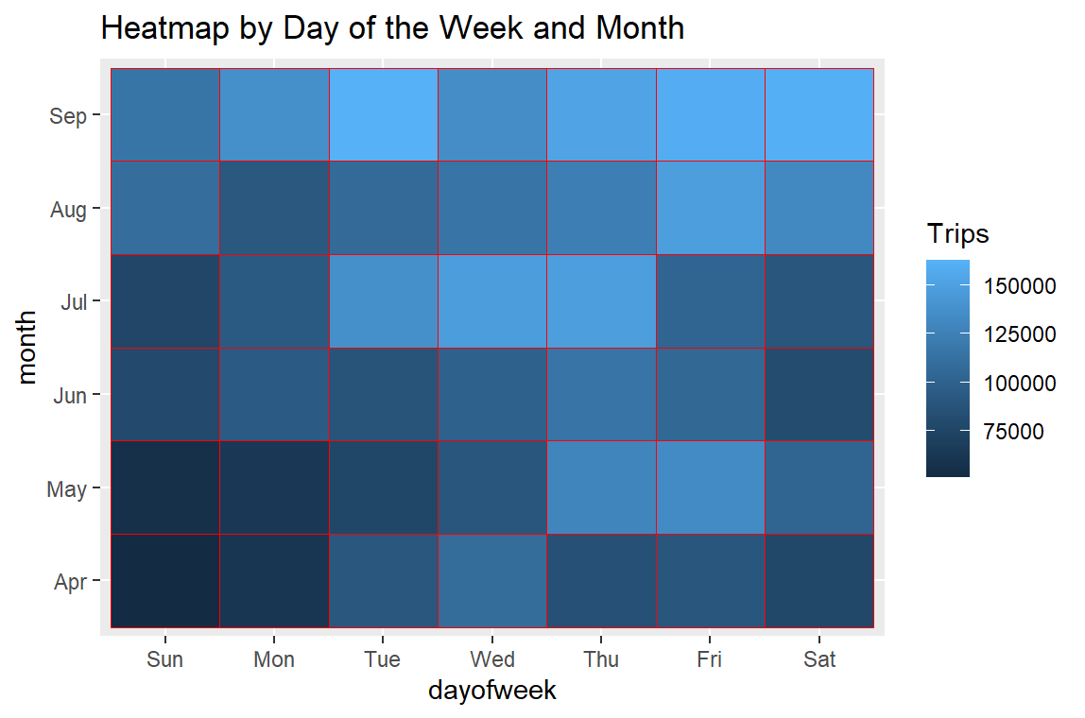

**A map visualization of rides in NYC**

